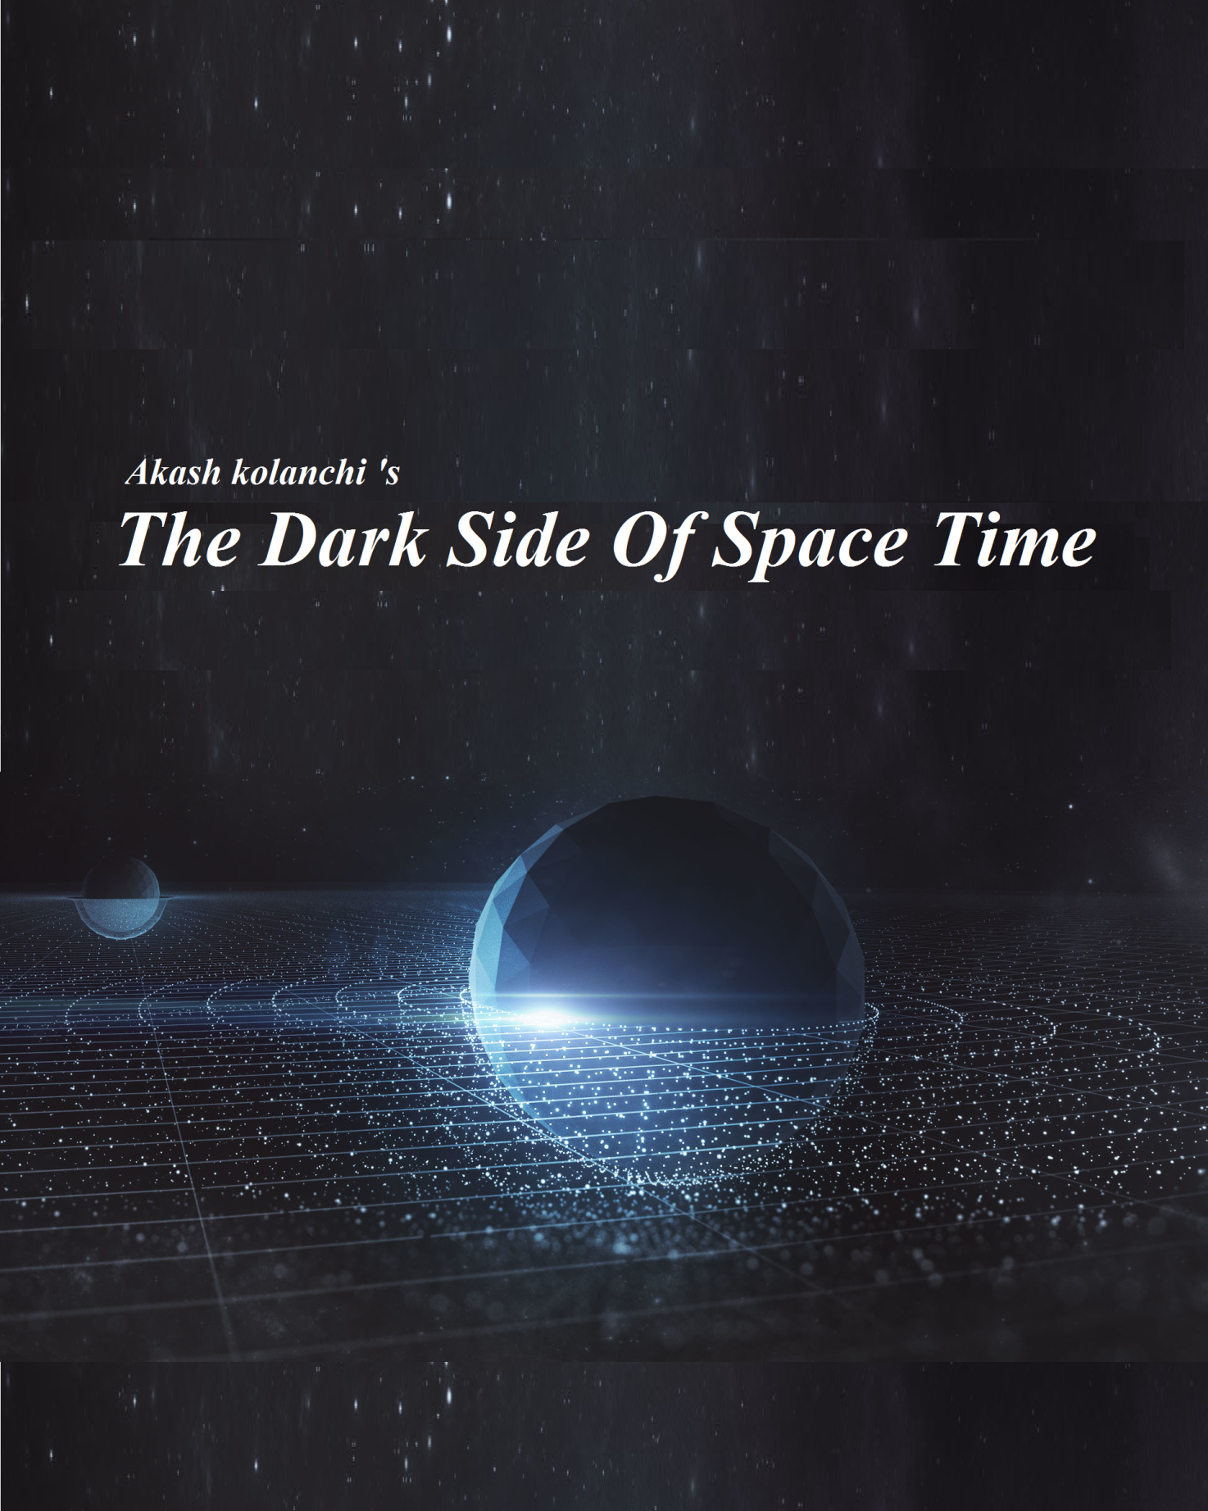

The Dark side of space time

Part 1

1st edition

Author- Akash Kolanchi

Publisher-24/7 publishing center

This book is dedicated to Nikola Tesla and all astrophysicist

An Introduction

This book is written by Akash Kolanchi. this book comprises of corrections on 4 scientists (Galileo, Newton, coulomb, Einstein) has a detailed explanation about gravity and charge gravity , says about various dimensions of shape ,quantum entanglement ,derivation for absolute equation for gravity, absolute equation for force based on Newton and Einstein’s relativity. This book might give an idea about space time curvature acceleration due to space-time curvature reason for space-time curvature, detailed study about 1D,2D,3D,4D, ND and says about time stress or potential relation between time stress and charge gravity , astronomical objects explanation(quasar, pulsar, blazar, neutron star, magnetar,black hole,white hole) relationship between black hole , white hole and Einstein Rosen bridge and you can know what actually happening at center of a black hole and unsolved mysteries of dark matter and dark energy is solved and you would be able to Imagine the end of the universe after reading this book. unsolved mysteries are given in this book and information about space time crystal

About author

Akash Kolanchi, popularly known as AkashTesla among with kith and kin is a big fan of scientific discovery. looking at this middle schooling, one can say he could be a successful and unsuccessful person in his life At most all of us will accept what famous scientist says. because we think they can’t be wrong . even if we have doubts in their theories we agree with because every on around us does so but this kid never accepted anything unless he had no doubts. at 11 th grade he claimed that Galileo statement “in the absence of air resistance, all bodies fall at the same rate ” is wrong . everyone around laughed at him . though he explained how Galileo was wrong, none of them cared about him humans generally think that educational qualification is proportional to our thinking capability no you can’t disagree with that yet , Akash didn’t think about quitting he took his claim to his physics teacher and explained everything finally his teacher said your right but the effect is negligible so you shouldn't consider its funny how the word negligible has been used by scientist to safeguard their theories that day was the birth of a legend who now alters perspective towards science of people around him with his mind-boggling theories I am damn sure that the day when Akash will be considered as the renowned scientist isn’t far away

By Mohan Vamsi.MS

CONTENTS pg no

1 Corrections on great minds 8

Galileo concept corrections

Newton concept corrections

Einstein concept corrections

2 Gravity 17

Derivation for gravity

Absolute equation of gravity

3 space time physics 22

Time stress

Force derivation

4 electro dynamics 25

Coulomb concept correction

5 theory of space availability 29

Kats’ laws of dimension

Dimensions (1d, 2d, 3d, 4d, nd)

6 Nomenclature 39

7 Space time oscillation 40

8 Dark matter 43

9 Astronomical events 47

Quasar

Pulsar

Blazer

Neutron star

Magnetar

Proto star

Rouge planets

Black hole

White hole

10 Quantum entanglement 60

11 space-time crystal 63

12 Answers to the big questions 67

CHAPTER-1

CORRECTIONS ON GREATEST MINDS

Galileo concept corrections

Galileo considered that “without any air resistance two objects with different mass fall at same rate ”

you exclaim that”how it can be wrong?”

There are some experimental proofs for Galileo’s concept ….but you can’t observe a time difference in the order of 10-10 sec in your naked eye

You can easily find a error in Galileo’s concept after the complete understanding of the term gravity

Gravity:

Gravity is the phenomenon of bending of space time fabric due to potential difference created by mass

Potential α mass

Consider a system of mass M and m

m

M

Mass (M) bends the STF towards itself and mass (m) bends the STF towards the mass(m) and so the net curvature is towards the greater mass and proportional to the modulus of the difference between the mass

ST curvature α ІM-mІ

From the above discussion

It is clear that…..

Gravity α |M-m|

Object with lesser mass experience more gravitational acceleration

“Without any resistance two objects with different mass falls at different rate” lower mass body falls first

Since gravity is weakest phenomenon

The Time difference is negligible for the experiment carried out for the proof of Galileo’s concept

Gravity is negligible in the sense mass is less capable to bend space time fabric or to create potential

Newton’s concept corrections

According to Newton gravity is a force and gravitational force is directly proportional to the product of their masses and inversely proportional to the square of the distance between them

Above sentence is approximately correct but not exact

Gravity-

Gravity is the phenomenon of bending of STF due to potential created by mass

Acceleration due to gravity (g) α difference b/w mass

Newton simply considered it as mass of heavy ones

Gravity can be solved by considering it as a force

Gravity acts as a force due to conservation of momentum

Kat’s 1st law of space time physics:

Acceleration due to space-time curvature is equal to partial derivative of potential difference between center of mass of two objects with respective x

Explanation of inertia

Concept of inertia can also be explained by space time mechanics

Consider two objects of vehicle and a box of mass m1 and m2 respectively

Let friction on the surface of the vehicle is zero

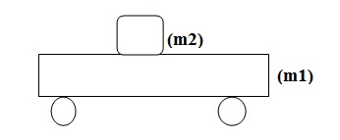 Let the vehicle starts to move with constant acceleration

Now the space time fabric of the box tries to keep the box on same position but the vehicle tries to move the box along its direction

Now the box need to move along the vehicles

Free body diagram of the box is drawn as

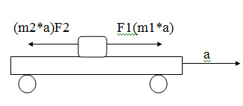

F1=F2

Due to conservation of energy

F1 force is used to move the box along the vehicle

And F2 force is inertia

Inertia:

Inertia is the reaction force exerted by an objected

While its carrier is accelerating

Einstein concept corrections

I know you will laugh at me while reading this topic

Einstein considered that mass/mass difference between two objects bends space time

Actually, the mass difference doesn’t bend space time …..But in case of gravity space-time curvature is directly proportional to mass difference but in a more generalized way potential difference bends space-time

Even charges bends space time fabric ……and mass is also a type of charge relatively we are positively charged by mass

Experiments on magnets

Elastic material is stretched and fitted to form artificial space time fabric or take trampoline and following is experimented

Experimental setup is shown in

Final observation is shown in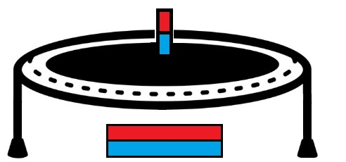

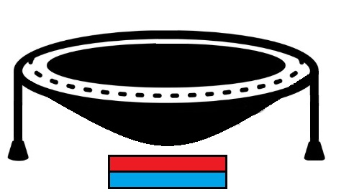

Space time curvature is similar to the experiments done by gravity

Experimental results by magnets resemble with experiments done by mass. But it doesn't resemble 100%

CHAPTER 2

GRAVITY

Gravity

From all the three corrections

We clearly conclude the concept of gravity

Gravity:

Gravity is the phenomenon of bending of space time fabric due to potential difference created by mass

Mass dilates time on another mass which produces some kind of stress say time stress(potential).space time fabric bends to nullify this stress

We all know …mass creates potential

Derivation of gravity

g=GM/R2-Gm/R2

Let bandicam 2019-04-18 14-46-24-510.jpg

Consider this diagram fig

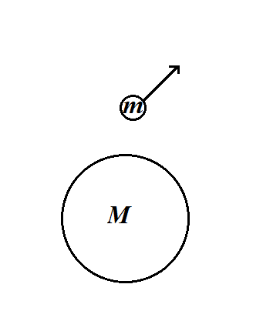

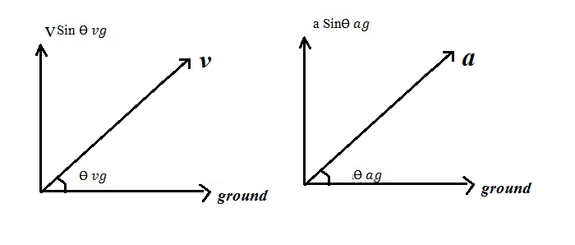 R changes with

bandicam 2019-04-18 14-46-31-007.jpg

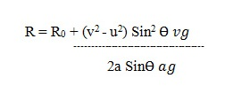

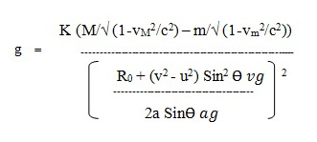

By neglecting relative factor and changes in R

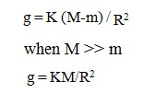

On comparing with the Newton’s equation

K = G

Hence the absolute equation for gravity

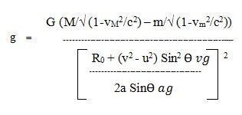

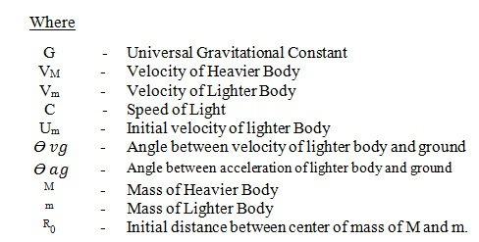

CHAPTER 3

ELECTRODYNAMICS

Coulomb’s concept corrections

According to coulomb electrostatic/magnetic force is directly proportional to product of their masses and inversely proportional to square of the distance between them

Above sentence is approximately correct but not exact

Charge Gravity-

Charge Gravity is the phenomenon of bending of STF due to potential created by charge

Acceleration due electrostatic force (g) α difference b/w mass

Charge Gravity can be solved by considering it as a force

Gravity acts as a force due to conservation of momentum

Kat’s 1st law of space time physics:

Acceleration due to space-time curvature is equal to partial derivative of potential difference between center of mass of two objects with respective x

Force = charge* charge gravity

Charge gravity derivation can be done easily by using derivation methods

Step1 find the potential difference between two charges at any point

Step2 divide it by r

Step 3 find the distance variation and substitute on the equation which came from step2

Step 3 Add relative factors for charges

Step

4 verify your derivation

CHAPTER 4

SPACE-TIME PHYSICS

Force:

Force is the rate of change of momentum, according to Einstein’s momentum dilation

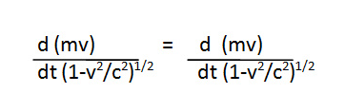

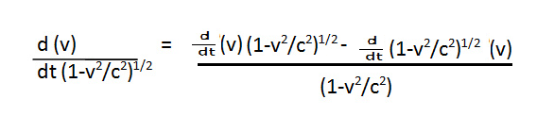

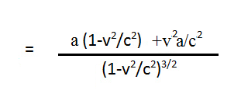

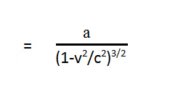

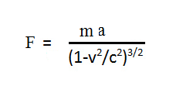

Time stress

Time stress is the type of stress developed on space time fabric due to time dilation. It is also called as potential

From studying the characteristic property of space-time curvature time stress is formulated as follows

Time stress = §G|M|/r (for gravity)

Time stress = §|kq|/r (for electro dynamics)

Where § is the sign constant

§ is product of sign of two charges

CHAPTER 5

THEORY OF SPACE AVAILABILITY

Theory of space availability

This theory explains says about the different dimensions related to available space

What is available space?

Available space is the total volume of an object

for a 1d object available space is its length, for a 2d object available space is its area and for a 3d object available space is its volume Let us consider a sphere of 1 meter

For simplification let us consider a circle of 1 meter

Total length of the line is equal to 2 π

Rotate the circle to form a sphere available space for square is equal to 4/3 π

Now I am going to explain about multiple dimensions

Our universe has three dimensions of space so we take first three dimensions as dimension of Shape

There are many dimensions of shape

Let us consider an object that is obtained when we draw a line of length(r) from a point to all directions in One dimension it’s a line in two dimension it is a circle in three dimension its sphere And name this object as SAGI

1d

Available space =2*r

2d

Available space = $2πr^{2}$

3d

Available space = 4/3 $πr^{3}$

4d

Available space = 2/3 $πr^{4}$

Kat’s laws of dimensions

Kat’s 1st law of dimension:

When actual space is greater than or equal to available space of object the object exist on space otherwise it distorts and forms such available space of object is equal to actual space of that universe

Kat’s 2nd law of dimension:

When the higher dimensional object enters into lower dimensional Universe it expands such that available space of higher dimensional becomes available space of lower dimensional object

Kat’s 3rd law of dimension:

If a lower dimensional object enters into the higher dimensional universe is does not undergo any changes

Dimensions

Now I am going to explain about four dimensions of shape and about nth dimension of shape

Let we take the objects SAGI to explain the different dimensions of shape

One dimension:

There is a single axis

Available space of SAGI is 2*r

Light travels in single direction in one dimensional universe

2r

Two dimension

It consists of two Axis which are perpendicular to each other

Available space of SAGI = $2πr^{2}$

The objects SAGI forms a circle

Light travels in both the directions in two dimensional universe

circle

Axis combine to form a plane

3 dimension:

It consists of three Axis which are perpendicular to each other

Available space of SAGI=4/3 $πr^{3}$

The object SAGI forms a three dimensional sphere

In three dimensional Universe light travels in all the three directions

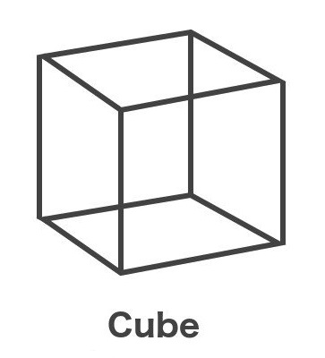

Three axis combine to form a cube

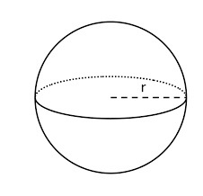

4 dimension:

It has 4 axis which are perpendicular to each other as we are three dimensional beings we can’t judge the shape of fourth dimension

Available space of SAGI=2/3 $πr^{4}$

In four dimensional Universe light travels in all IV direction

The objects SAGI forms 4th dimensional sphere

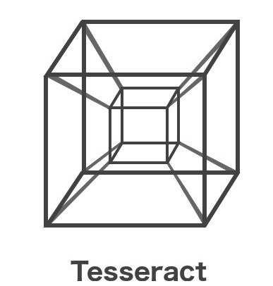

Four axis combine to form tessaract

N dimension:

It has n axis

As we are three dimensional beings we can’t judge the shape of n dimension

All n axis are perpendicular to each other

Available space of n dimensional SAGI=2n/n! $πr^{n}$

*

The given object SAGI forms a n dimensional sphere

CHAPTER 6

NOMENCLATURE

Nomenclature for axis

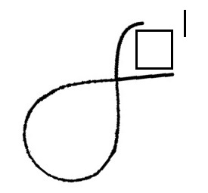

Dash symbol is used for representing opposite axis

Nth number of axis is written in the box

For naming different axis symbol Aki is used

E.g.:

For the representation of 3D axis replace x, y, z with

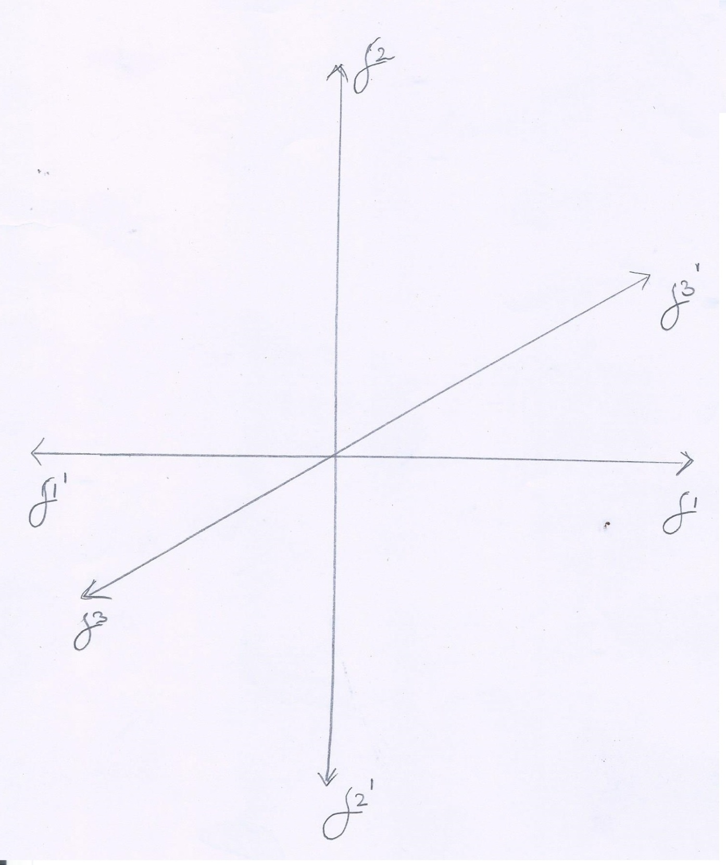

Symbol is called as aki and x axis is read as aki1 and x dash axis is read as aki dash 1 axis and so on……

CHAPTER 7

SPACE TIME OSCILLATION

Space time oscillation

Space time fabric does not bends directly from one point to another space time fabric oscillates this is experimentally shown by bellow experiment

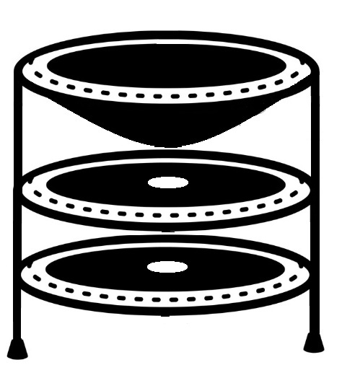

The trampoline is torn such that after a certain expansion of trampoline the central hole on trampoline starches such it releases the ball

Now we are going to the interesting part of this topic….

KAT’s Dark Time Space

The whole universe is made up of space time fabric and rest of the space is filled with dark time space the representation of whole universe is shown by fig

Light actually requires a medium to travel i.e, space time fabric

Black band represent dark-time space, white lines represent space-time fabric

Space-time fabric conducts electromagnetic waves, light Dark time space is dark because there is no space-time fabric Dark time-space is the key to many unsolved mysteries……….. Let us talk about one of them

CHAPTER 8

DARK MATTER

Dark matter

Dark matter does not react with light its existence is known by gravitational effect, bending of light, dark matter is baryonic matter ……some scientist suggest dark matter is non baryonic matter

Dark matter is a baryonic matter i.e. it consist of protons, neutrons, electron and all other subatomic particles but this matter exist in dark time space. Universe is comprised of space time fabric and dark time space mostly with dark time space and we positioned in space time fabric because you are able to read this book with help of light and light is conducted by space time fabric. Universe is comprised like atom .atom consist of 99% space but we are able see matter not space. Like universe is mostly comprised of dark time space and we are unable to see dark time space because of space time oscillation. If there is any dark time space between cap of the pen and bottom of the pen you can’t see the dark time space you will be able to see the whole pen consider the

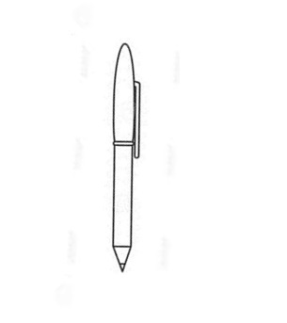

We see the pen as above picture…but actually

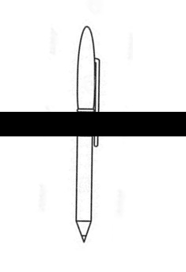

This is not exact representation…this a representation for understanding purpose…exact diagram is complex

Consider the experiment on fig…the trampoline is space time fabric and air is dark time space

Another possibility of dark matter

Dark matter is non baryonic matter I,e. it is not comprised of protons and electrons ,instead it is comprised of neutral particles and has the structure of atom .gravity is reason for the neutral particle to revolve a neutral particle .it consist of 99.99999996% of empty space …and concepts of light in baryonic matter physics doesn’t applicable here .dark matter does not interact with light.but we can trace out the dark matter only because of its gravity

CHAPTER 9

ASTRONOMICAL OBJECTS

Quasar:

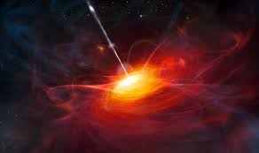

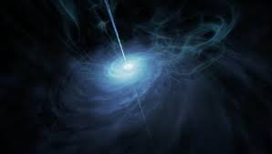

A quasar or quasi-stellar object is an extremely luminous active galactic nucleus (AGN).quasar was first identified in 1950 As gas falls towards the black hole, energy is released in the form of electromagnetic radiation, which can be observed across the electromagnetic spectrum. the enormous amount of power is radiated by quasar.the contraction of word quasi-stellar leads to quasar, due to its high rotation speed quasars are the most spherical objects in the known universe. some quasars exhibit apparent superluminal motion

Pulsar:

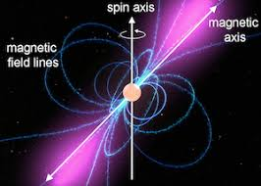

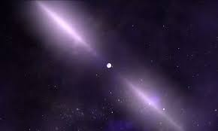

A Pulsar is a highly rotating magnetized neutron star which emits a beam of electromagnetic radiations. the radiations can be observed only when the electromagnetic beam is pointing towards earth, this is the reason for pulsed observations of emission beam. the time interval between each pulse ranges between milliseconds to second,pulsars is one of the sources of ultra high energy cosmic rays.

Neutron star:

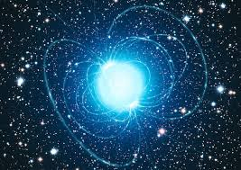

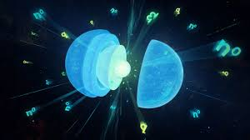

Neutron star is a star formed after super novae explosion mostly comprised of neutrons .atom consist of 99.9999999996% of empty space but neutron star consist of 1% empty space this is the reason why the density of neutron star is so high and due to high gravitational force density even more increases.there are different types of neutron star

Magnetar:

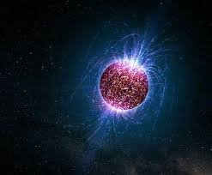

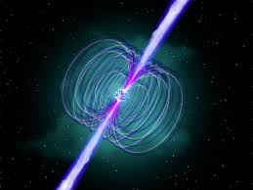

Magnetar is the type of neutron star which has extreme magnetic field about 109-1011 tesla . the magnetic decay pwers emmision of high energy electro magnetic radiation,x rays,gama rays

Blazar:

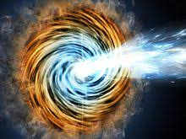

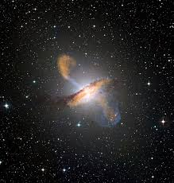

Balzar is an active galactic nucleus(AGN) with a relativistic jet comprised ionized matter traveling at nearly the speed of light. Blazars are the powerful source of emission in the electro – magnetic spectrum and observed to be the sources of high enegy rays say gama rays.the exibit super lumial motion.blazars are highly variable source,often undergoing rapid and dramatic fluctuations in brightness on short time interval

Nebula :

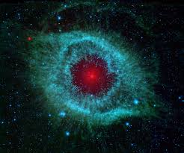

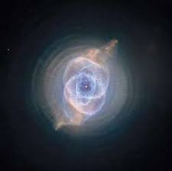

Nebula is an cloud of dust ,hydrogen , helium and other ionised gases. Nebula is a latin word means cloud or fog. The term was used to describe any diffuse astronomical object including galaxies beyond the milky way.many nebulae are visible due to fluorescence caused by embedded hot stars

Protostar

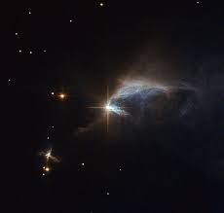

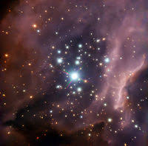

A prortostar is a very young star that is still gathering mass from its parent molecular cloud .protostellar phase is the earliest one in th process of stellar evolution.protostellar phase begins when a molecular cloud fragment first collapses under the force of self gravity.it ends when the infalling gas is depleted , leaving a pre-main-sequenc star

Rouge planet:

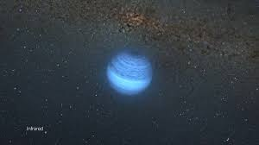

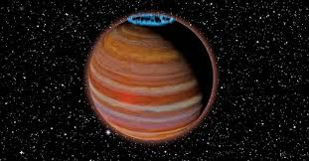

Rouge planet is a planetary-mass object that orbits a galactic center directly .such objects have been ejected from a the planetary system in which they formed or have never been bound with any star. The miky way alone may have billions of rouge planets.  the International Astronomical Union has proposed that such objects be called sub-brown dwarfs. A possible example is Cha 110913-773444, which might have been ejected and become a rogue planet, or otherwise formed on its own to become a sub-brown dwarf.

Black hole:

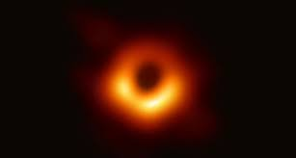

We witnesed the first image of balck hole on 10/04/2019 by Event horizin telescope (EHT).this blury image is a big leap in physis . this image boosted our ivilisation. We fall on some species in the universe who witnesed the image of black hole . Einstein’s relativity passed another test.if we witnessed HD image of black hole it might look like a black hole which is shown on interstellar movie(2014)

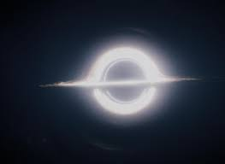

Black hole is a neutron star which satisfies the black hole equation

When a star undegoes super novae explosion it either convert into a neutron star or a black hole depends upon the mass of the star. Black hole comprises of neutrons when a object enters into a black hole it becomes electrically neutral and become a part of black hole leading to expansion of event horizin.black hole has accreation disk on 3 swarchild radius , photon sphere on 1.5 swarchild radius

White hole:

We never witnessed a white hole because practically it doesn’t exist. White hole is a matter negative matter system. There is parallel universe exist on other side of the universe in wich all particles are made up of negative matter.

Let us consider a matter negative matter system

Consider a negative matter palanet and matter particles

Reach velocity is the velocity require for the particle to reach the planet .when it reaches the surface matter and negative matter to form nothing

Reach veocity derivation

Mass of the planet= -M

Mass of the particle=m

Radus of the planet

By conservation of energy

0+1/2*mvr2=GMm/r

Vr=(2GM/r)1/2

For a white hole even light should not reach it’s surface

By equating we get

2GM/r > c2

Where M is the mass of white hole r is the swarchild radius of the white hole

Equation of black hole and white hole are same black hole is the matter matter system , white hole is the matter negative matter system . a black hole made up of negative matter acts as a white hole in our universe(matter universe)

There may be a artificial white hole created by intelligent spices . to create a negative matter we should separate mtter and negative matter from nothing for that we should need a kadol which detailled in preceding chapter,when a black hole white holes are sparated by some distance einstein rose bridge forms. Black hole may connect us to parallell universe

CHAPTER 10

QUANTUM ENTANGLEMENT

Quantum entanglement

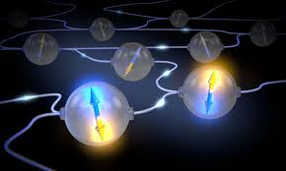

Two entangled particles doesn’t share quantum inforatiom which is instataneous. They actually folow physics. We can expain charcerstic of entangld particles with anti entangled particles . take me ‘akash’ and paralell akash who is locted on mirrored space co-ordinate and same time co-ordinate . take some time interavall of 1 min suppose I am doing something he will also do what I do because we both have same brain complex, finger print ,same height , same weight …everything same we both are grown in different places but our environment is same we have same friends same air pressure,blood pressure ...every thing. We respond same answers to same questions. We are positively charged matter particles with our point of refernce but when it comes to absolute point of reference our we and our paralell universe are in measuring mater charge.if we are able to measure charge of the matter , when we measure our matter charge as positive charge of paralell universe becomes negative and when we measure our matter charge as negative charge of paralell universe becomes positive. This what happens in measuring spin of electron when you calculate spin of one electron as clock wise other one become anti clockwise and when you calculate spin of one electron as anti clock wise other one become clockwise

CHAPTER:11

TIME CRYSTAL

Time crystal:

Time crystal is the type of four dimensional matter in which it follows certain pattern in time . crystal follows some certain pattern in 3 dimensional geomerty, like wise time crystal follows certain pattern as time passes. It is a type of non-equlibirium matter thus it doesn’t thermal equilibirium. This state of matter cannot be isolated from its environment . ot is an open system. Symmetries in nature lead directly to conservation laws, something which is formulated by noether theorem. Time crystal breaks the time translation symettry. It bridges the gap between general relativity and quantum mechanics. Its first appilication could be in quantum computing. Time crystal with with their strong flip cycle could be the next step in stable quantum memory which is the building block of quantum computers. In digital computers we use 0and1 in quatum compuers

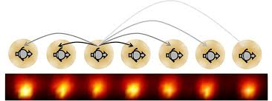

Norman yao studied studied about different types of time crystal. he did some mathematical calculation and ploted the phase diagram between interaction strength between atoms versus imperfection in spin flip counting

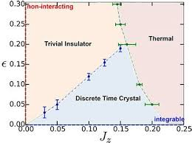

His blueprint was successfully used by two teams: a group led by Harvard's Mikhail Lukin and a group led Christopher Monroe at University of Maryland.

In October 2016, Christopher Monroe claimed to have created the world's first time crystal. Using the idea from NormanYao's proposal, his team trapped a chain of ytterbium (171Yb+ ) ions in a Paul trap, confined by radio frequency electromagnetic fields…..another team on same year  Mikhail Lukin at Harvard also reported the creation of a driven time crystal. His group used a diamond crystal doped with a high concentration of nitrogen-vacancy centers, which have strong dipole-dipole coupling . This strongly-interacting dipolar spin system was driven with microwave fields, and the ensemble spin state was determined with an optical (laser) field. Time crystal is a state of matter in which it follows certain pattern in space and time . gases don’t follow any pattern in space, crystals follow certain pattern in 3-dimensional geometry i.e. space , space-time crystal follows certain pattern on both space and time ……there is a possibility of matter to follow certain pattern on time only

CHAPTER 13

KAT’s wave equation

Scrodinger wave equation approches quantum mechanics in probabilitistic approch while KAT’s wave equation approches in a realistic way it defines a velocity function for a wave function which leads you to determine exact posistion of electron

Scrodinger’s wave equation

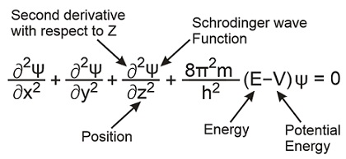

KAT’S WAVE EQUATION

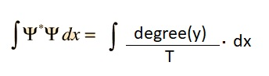



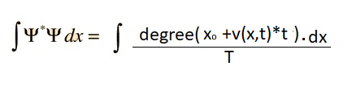

By scrodinger’s wave equation

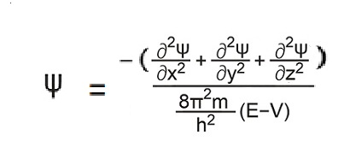

Substitute in 1st equation

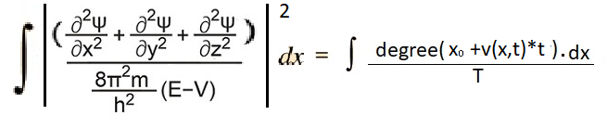

Above equation is the final form of KAT’s wave equation

Defining all constants

Y

Si

T

t

v

v(x,t)

x0

CHAPTER 14

QUANTUM OBSERVER EFFECT

To understand quantum observer effect you must able to understand dual nature of electron and experiments such as electron double slit experiment to understand it

Experiments:

Single slit experiment

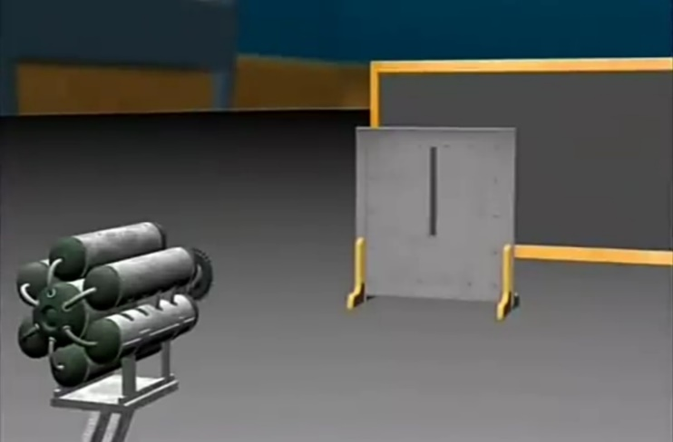

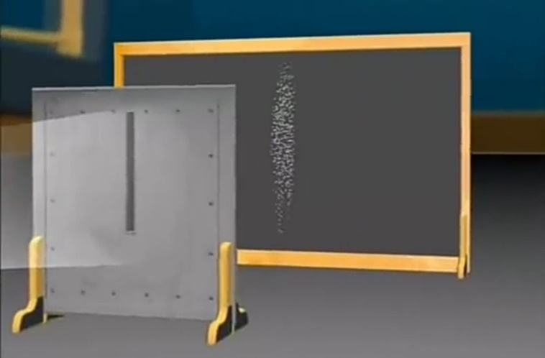

Eprimental relusts showed that electron is a particle but wait we can’t conclude that electron is a particle by this experiment because both particle and wave has same results for single slit experiment there is possibility that electron is a wave so lets confirm by double slit experiment

Double slit experiment:

Experiment setup is same as single slit .here we replace single slit with double slit. And the result should be more like a result yeilded with particles but here its different we got an interference pattern which is a result yeilded from double slit experiment of a wave after all electron is a particle so some people said that its because of collision between electron which makes an interference pattern in double slit experiment to test this theory scientists conducted another experiment . the same double slit experiment but this time they’ve shooted one electron at a time so that there is no chance of collisions between electrons . after some time thae result showed an innterference pattern this experiment disproves the theory of collisions between electron

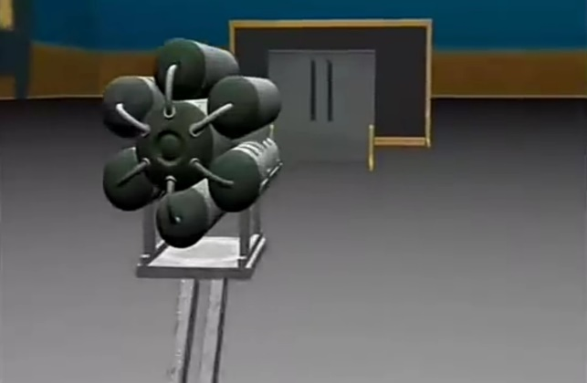

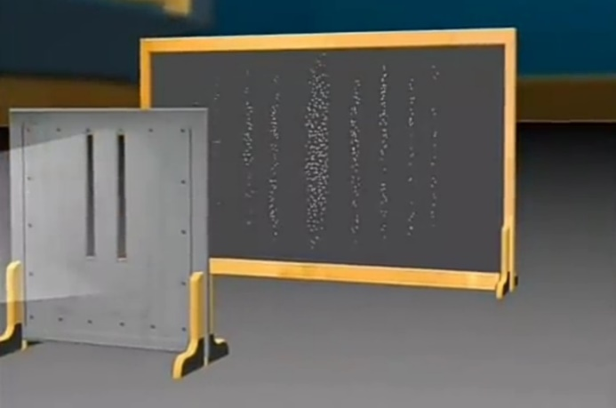 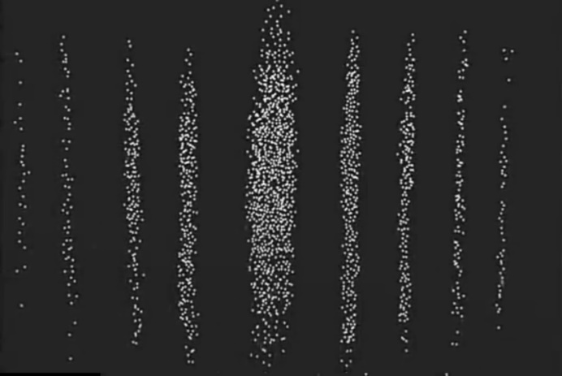 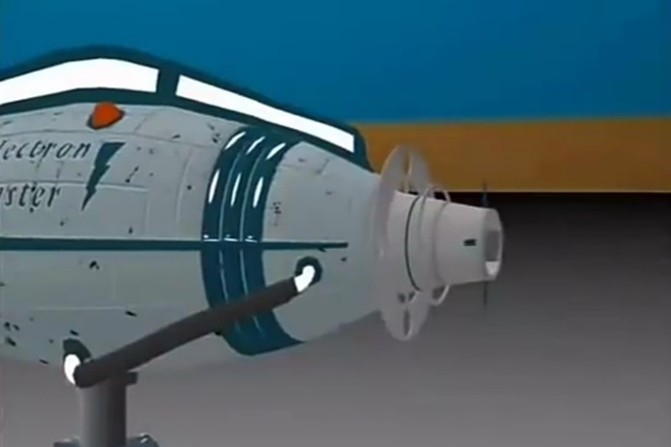

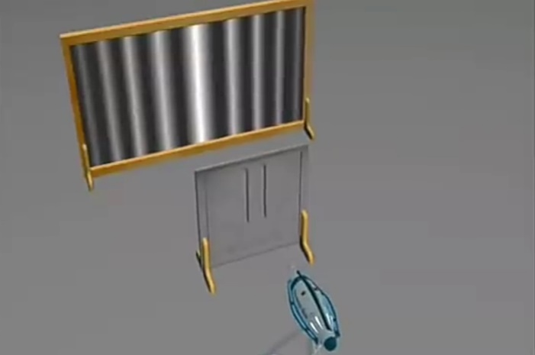

To know how the electron is behaving like a wave they’ve set a device to observe the path this time electron choose a single path which means it acted like a particle ad the results in double slit experiment showed the same it yeided the result of a particle in a double slit experiment



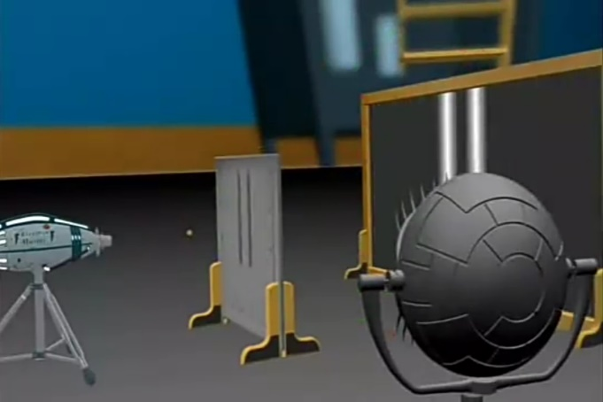

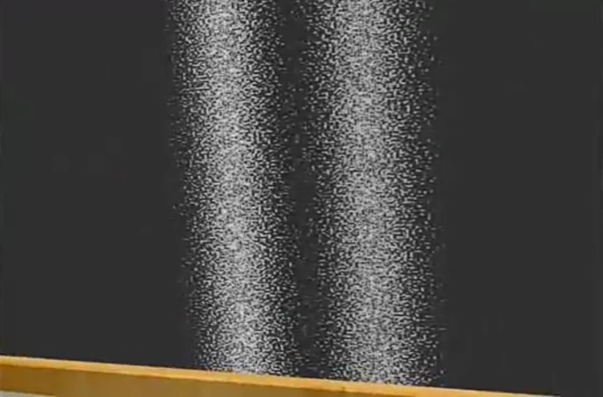

The phenomenon of changing of character from wave to particle by siply observing them is known as observer effect

CHAPTER 15

SOLUTION TO QUANTUM OBSERVER EFFECT

According to my theory electron behaves as both matter and wave depending on the force applied by means of gravitation energy . electron moves through sapce and time thus it releases gravitational waves or it emmits some kind of radiation say T radiation this T radiation emmited continuously as it moves through space all the way . this works as similar to emmision of light when an electron jumps higher energy state to lower energy state in that case it varies electrostatic potential here the electron varies through gravitational potential . electron moving through space-time fabric is considered as moving through different gravitational energy fields a single space-time fabric is considered as a single energ level thus the electron emmits T radiation spontaneously. Emmision of T-radiation is reason for the electron to behave as a wave that’s why electron in double slit experiment when it’s shooted by one by one which ends up with a result of interference pattern

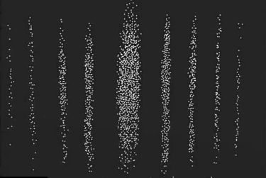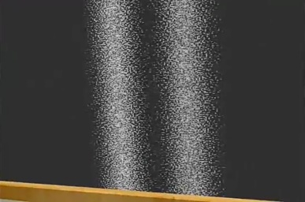

but when we place a observer on the path of elctron to observe it. It behaves like a particle which results in two patterened probabilitic stipes which is showed in (fig-.1)

this happens because observing the electron leads to break in T-radiation symmetry

T-radiation symmetry

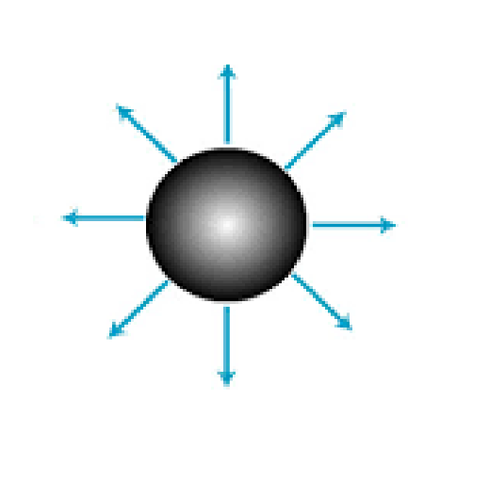

T-radiation broken symmetry

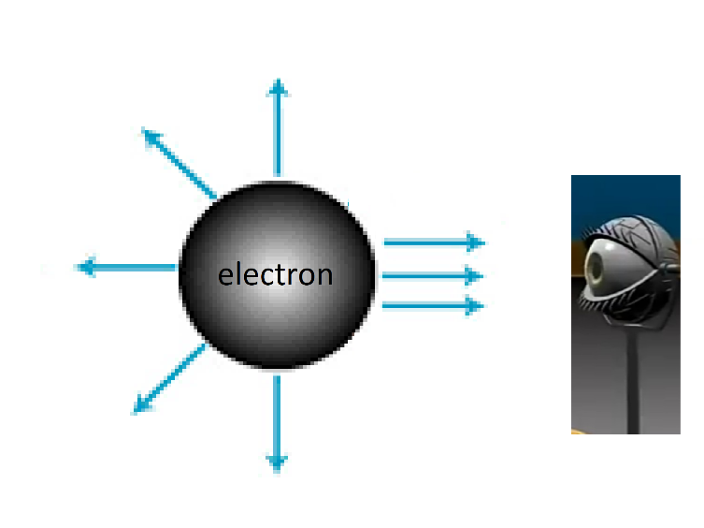

T-radiation:

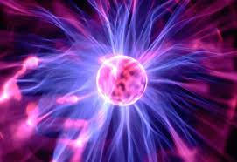

T-radiation is radiation which is emmited when a object travells through space time strings (ie, through gravitational potentials)

CHAPTER 16

THINGS THAT SUPPORT MY THEORY

1. Speed of gravity

We all know that speed of gravity is same as speed of light this phenomenon supports theory of space time oscillation space time fabric is the one which conducts electromagnetic radiation(ie, light ) . photon actually travel at infinite speed as photon requires a medium to travel i.e, space time fabric and photon travells in the maximum allowed speed due to space-time oscillation (speed of light ) and as effect of gravity is caused by space-time oscillation and so effect of gravity travells at speed of light.

CHAPTER 17

NUX ORIGIN THEORY

CHAPTER 18

SPACE TIME CONSERVATION

Space time conservation states that summation of space factor time factor and energy factor of two different states remains constant wile travelling same

Space factor+energy factor+time factor=const

Time factor = A*t2

Space time is applicable for 4d beings. we are also 4d beings but sincle our rate of flow time is practically I,e approximately constant we are following space physics this the reason why we have difficulty in understanding quantum mechanics and this also the reason for quantum fluctuation for us humman body(macro body) our space energy ie e=mc2 when compared to the energy compared to time enrgy caused by time dillation the enrgy caused due to our space velocity which causes time dilation there by resulting time accelaration ie double derivative of time with respective distance . now we are separating time physics from spacetime physics so that we can easily understand space time physics.

TIME PHYSICS:

Lets start this with some basic terms that helps in understanding a a 4D object to understand time physics we need some basic terms like velocity accelaration etc in this case of time physics we will take the rate of flow of time as time velocity.

Time dynamics:

When we consider time to flow there are many changes happens in total physics, for 4d beings when rate of time flow accelarate thus there is some eternal time force acts on 4D object and so messing up with total physics we’ve studied. For 4D beings there

CHAPTER 12

ANSWERS TO THE BIG QUESTIONS

Answers to the big questions

After reading this book I think you have benn confused …many questions arrises in your mind .I read this book as a normal human not as author and there are some doubts arrised in my mind I mentioned here so that you can have some clar understanding

**Question 1 what is the difference between actual distance an relative distance?**

Actuall distance is the distance measured by considering space time fabric width and dark time space . we must use actuall distance for calcution in gravity ,electrostatics , magnatism but we get correct answers whn we use relative distance.relative distance is the distance measured by considering only spacetime fabric width that’s what we measure.

**Question 2 what is actual space of universe and available space of object?**

Actual space of universe is the capacity of space wich can be inserted in a unit volume.available space of object is the total volume of the objec.for 1d object it is total length,for 2 d object it is total area,for 3d object it is total volume…et

**Question 3 Does dark time space affects gravity**

Yes,dark time space affects gravity.for calculation of gravity we should take the actuall space between two points. We get correct answers because actuall distance is equal to relative distance multiplied with some constant say, dark space constant .we don’t know the exact value of dark space constant. If we are able to claculate the value of universal gravitational constant(G) theoritically we can calculate the value of dak space constant.value of G calculated theoritically will not match with the G that we are using now

**Question 4 what bends space time fabric?**

Space time bends because of time stress in other words potential ,hence the things which creates the potential bends space time fabric.all charges i.e, mass,electic charge,magnetic charge….positive electric/magnetic charge creates potential on negative change and vice versa and positive mass creates potential on another positive mass, negative mass creates potential on another negative mass.

**Question 5 is there is god ?**

No there is no god there may be a creator, but he has nothing to do with us, if there is a creator, he must have died now. Concept of the creator is not what you think he can’t do anything like you imagine i.e. flying, walking in water, creating energy…etc. I would go with Stephen Hawking, nothing to confuse with..There is no god, no creator, no $#! +, nothing

**Question 6 Are we simulated?**

There Is a possibility that we are simulated ,we cant judge weather we are simulated or not because the evidence which says “we are not simulated” may be a simulated evidence. It is also possible that the physics what you have learned from your childhood to now may be simulated .even our games follow different physics.another possibility says that god you worship are the alien software engineer who developed the simulation .dont worry this is a possibility.”if all beings follow natural equation(i.e karma) there is high chance that we are simulates “

**Question 7 what do you think about orgin of the universe**

I will explain it in another book

A K A S H T E S L A

Follow me on instagram @akashkolanchi

For any queries or mistakes on your point of view mail it to [akashktesla@gmail.com](mailto:akashktesla@gmail.com) with subject querie on your book

Special Thanks to Book possible.

Thanks to astrogeekz, astromate and other many pages for feedig me knowledge

